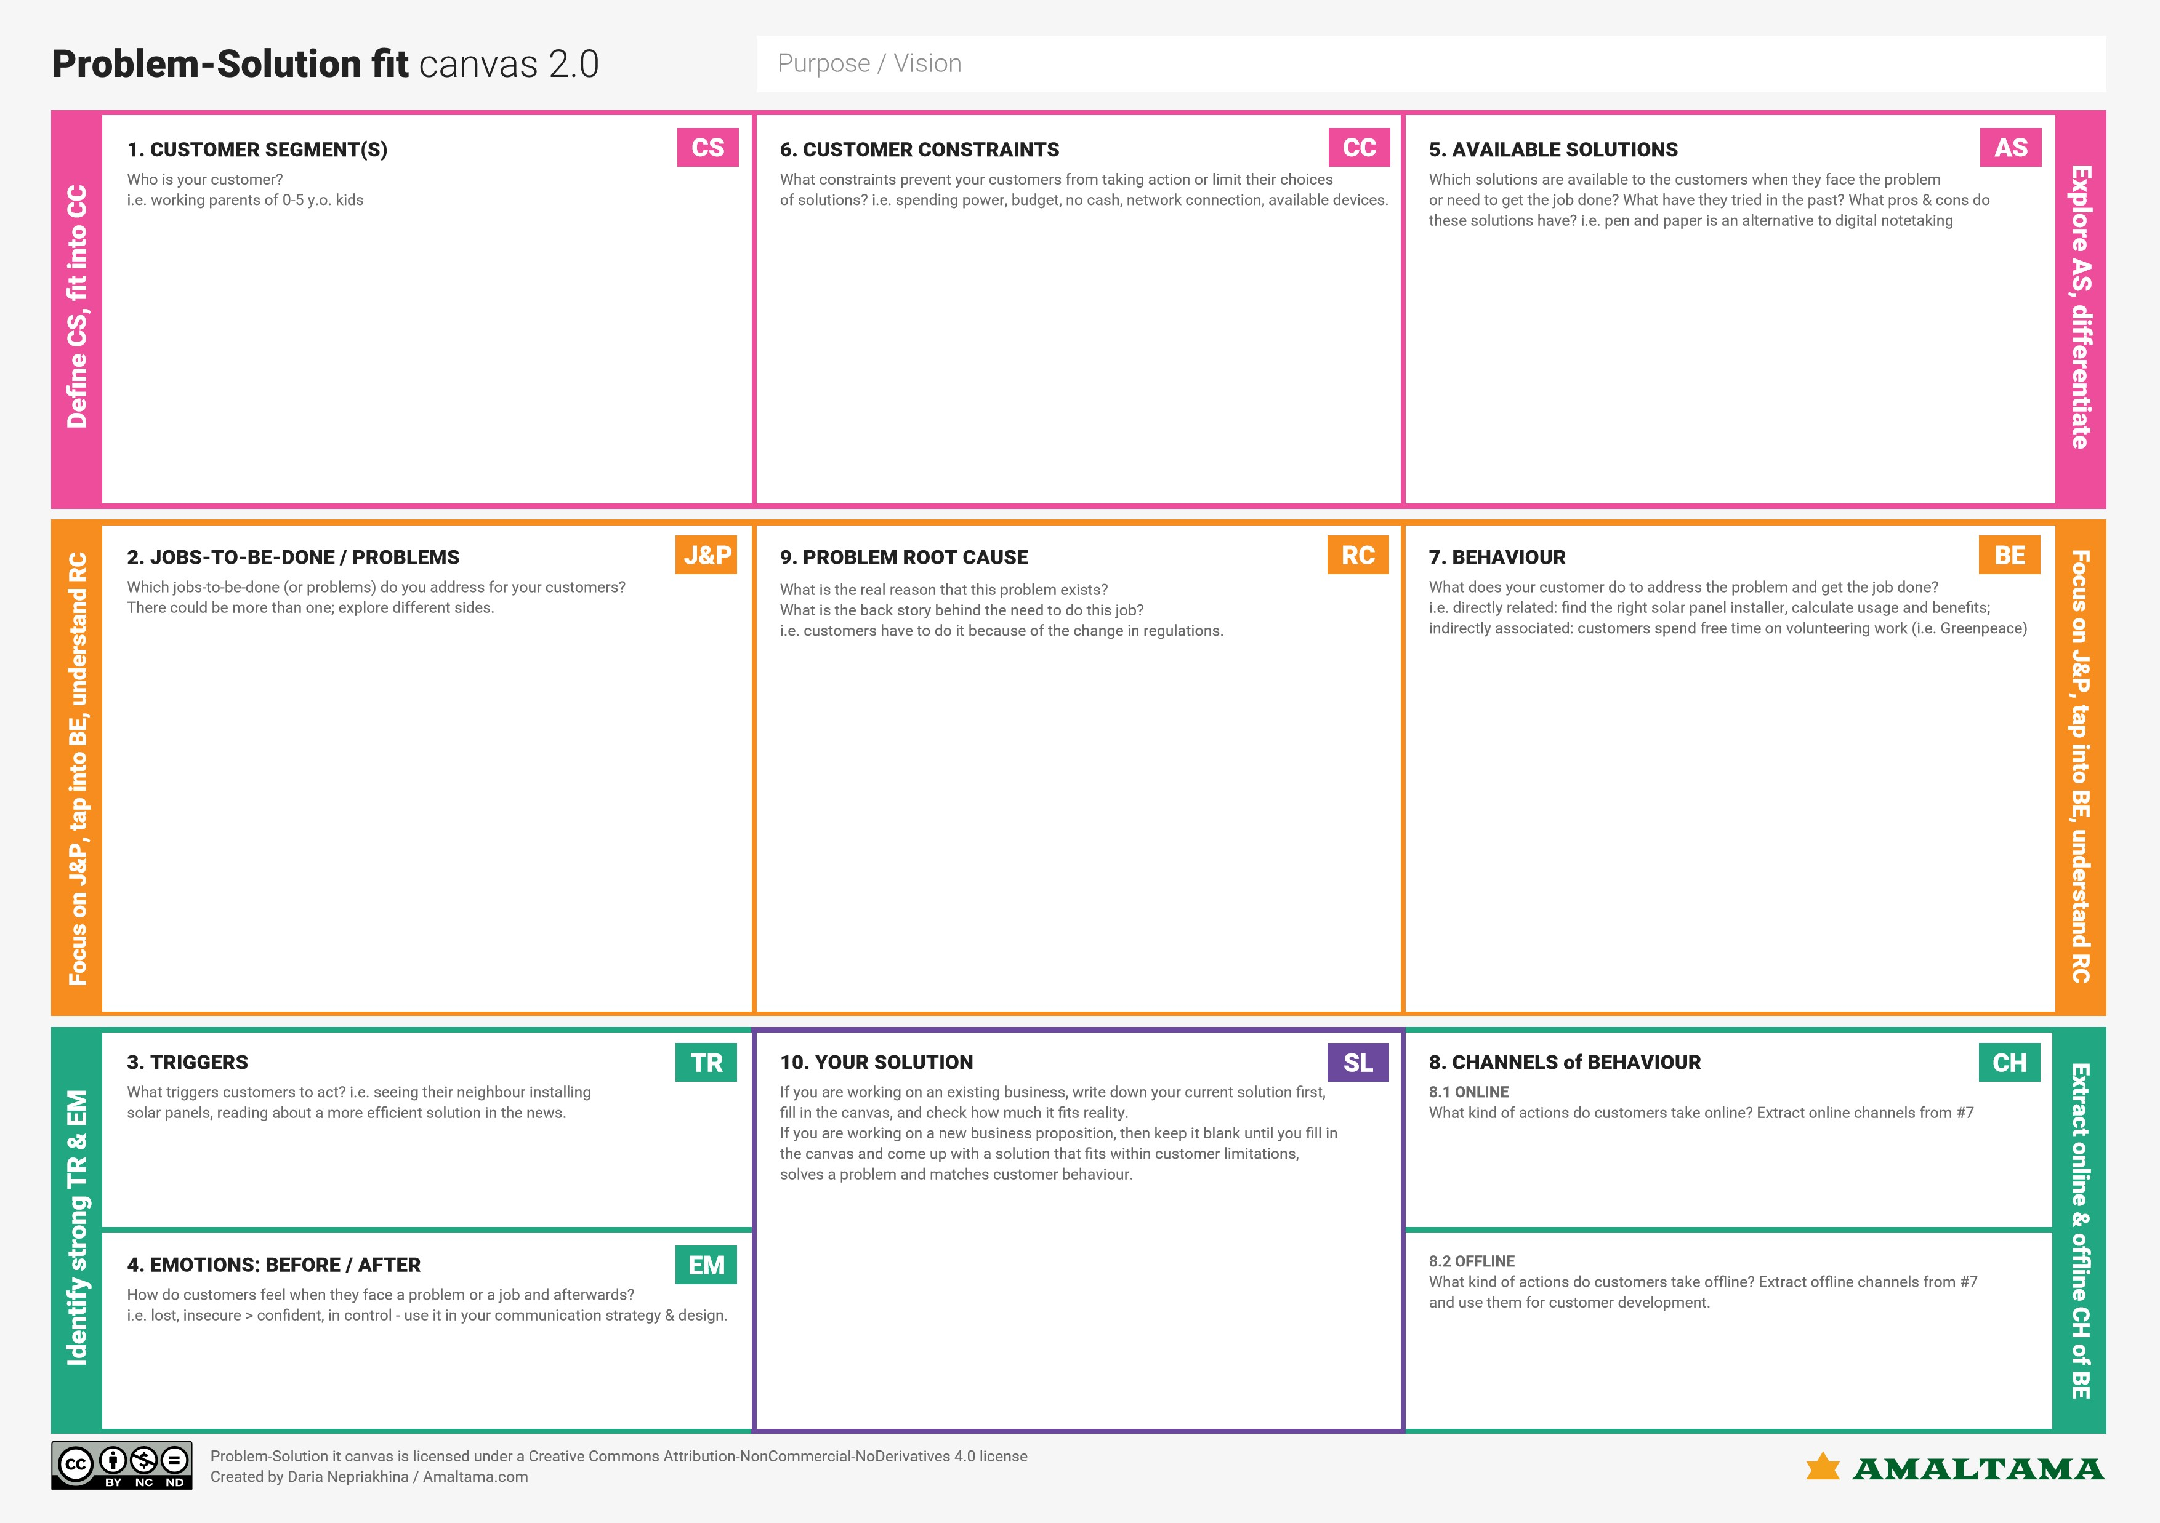

Financially literate customers are more profitable because “They are credit-driven and have a higher usage of depository products”.

To evaluate the unwanted expenses and in money management and it will help to improve financial stability.

Our customers are illiterates, trustees, joint account holders, executors and administrators, Power of attorney holders.

Safety, Payment of expenses, savings, accessibility.

Online: Customer can easily access the various services collections and payments.

Bank service customers cannot be perceived as a homogeneous group, because that customers are “emotionally attached customers”.

As I already convey the message that the main solutions have been obtained by tracking the personal expenses. It will help to track the purchase history and list daily expenses and provide money saving plans.

Offline: offered by the bank themselves with the assistance of a bank officer.

Financial triggers are situations or emotions that nudge us to do something that does not align with good financial health.

Bank customers behaviour customer behaviour refer to an individual’s buying habits, including social trends, frequency patterns, and background factors influencing their decision to buy something.

The funds received from the commercial banks are of short duration and the procedure of obtaining funds in a time taking affair as there is a lot of verification that needs to be done from the bank end.